1.

Xml:

<?xml version="1.0" encoding="utf-8"?>

<LinearLayout xmlns:android="http://schemas.android.com/apk/res/android"

xmlns:tools="http://schemas.android.com/tools"

android:layout_width="match_parent"

android:layout_height="match_parent"

android:orientation="vertical">

<ListView

android:id="@+id/languages01"

android:layout_width="match_parent"

android:layout_height="wrap_content" >

</ListView>

</LinearLayout>

Java:

package com.example.lidtview;

import androidx.appcompat.app.AppCompatActivity;

import android.os.Bundle;

import android.view.View;

import android.widget.AdapterView;

import android.widget.ArrayAdapter;

import android.widget.ListView;

import android.widget.Toast;

public class MainActivity extends AppCompatActivity {

String msg;

private ListView mListView;

private ArrayAdapter aAdapter;

private String[] languages = { "Android","Java","Php","Hadoop","Sap","Python","Ajax","C++","Ruby","Rails","C"};

@Override

protected void onCreate(Bundle savedInstanceState) {

super.onCreate(savedInstanceState);

setContentView(R.layout.activity_main);

mListView = (ListView) findViewById(R.id.languages01);

aAdapter = new ArrayAdapter(this, android.R.layout.simple_list_item_1, languages);

mListView.setAdapter(aAdapter);

mListView.setOnItemClickListener(new AdapterView.OnItemClickListener() {

@Override

public void onItemClick(AdapterView<?> parent, View view, int position, long id) {

Toast.makeText(getApplicationContext(),languages[position],Toast.LENGTH_LONG).show();

}

});

}

}

Output:

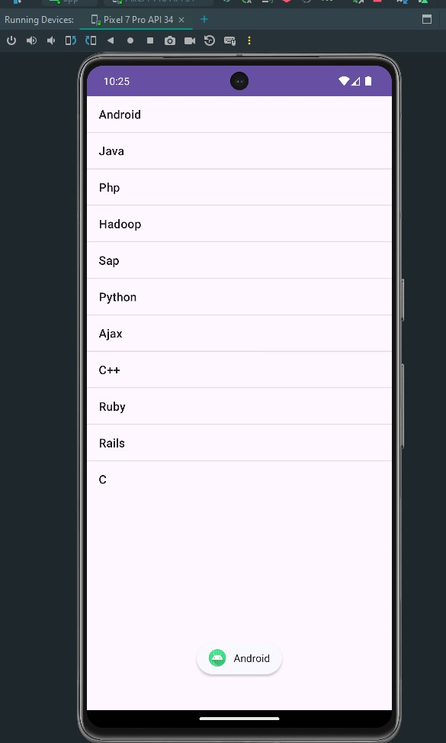

2.

Xml:

<?xml version="1.0" encoding="utf-8"?>

<RelativeLayout xmlns:android="http://schemas.android.com/apk/res/android"

xmlns:tools="http://schemas.android.com/tools"

android:layout_width="match_parent"

android:layout_height="match_parent"

tools:context=".MainActivity">

<ImageView

android:id="@+id/imageView"

android:layout_width="wrap_content"

android:layout_height="wrap_content"

android:scaleType="center"

android:layout_centerInParent="true"

android:src="@drawable/image1" />

<Button

android:id="@+id/changeImageButton"

android:layout_width="wrap_content"

android:layout_height="wrap_content"

android:text="Change Image"

android:layout_marginTop="20dp"

android:layout_below="@id/imageView"

android:layout_centerInParent="true"

android:onClick="changeImage" />

</RelativeLayout>

Java:

package com.example.practical1402;

import android.os.Bundle;

import android.view.View;

import android.widget.Button;

import android.widget.ImageView;

import androidx.appcompat.app.AppCompatActivity;

import com.example.practical1402.R;

public class MainActivity extends AppCompatActivity {

private ImageView imageView;

private Button changeImageButton;

private int currentImageIndex = 1;

@Override

protected void onCreate(Bundle savedInstanceState) {

super.onCreate(savedInstanceState);

setContentView(R.layout.activity_main);

imageView = findViewById(R.id.imageView);

changeImageButton = findViewById(R.id.changeImageButton);

}

public void changeImage(View view) {

currentImageIndex = (currentImageIndex == 1) ? 2 : 1;

String imageName = "image" + currentImageIndex;

int resourceId = getResources().getIdentifier(imageName, "drawable", getPackageName());

imageView.setImageResource(resourceId);

}

}

Output:

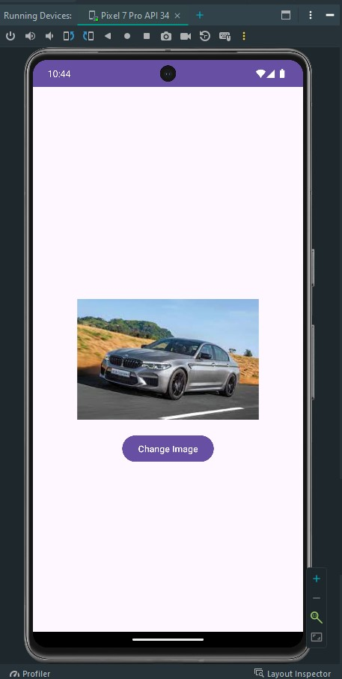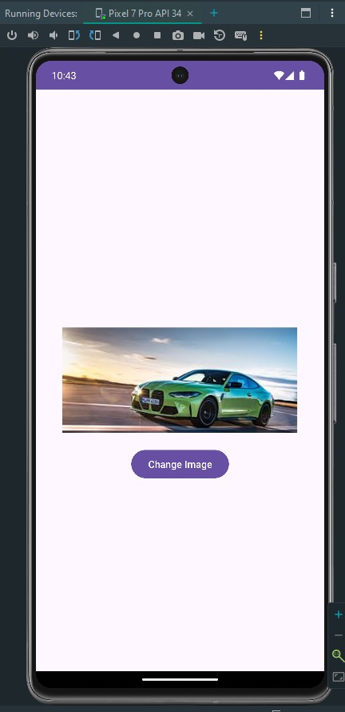

3.

Xml:

<?xml version="1.0" encoding="utf-8"?>

<RelativeLayout xmlns:android="http://schemas.android.com/apk/res/android"

xmlns:tools="http://schemas.android.com/tools"

android:layout_width="match_parent"

android:layout_height="match_parent"

tools:context=".MainActivity">

<GridView

android:id="@+id/gridView"

android:layout_width="match_parent"

android:layout_height="match_parent"

android:columnWidth="100dp"

android:gravity="center"

android:numColumns="auto_fit"

android:stretchMode="columnWidth"

android:horizontalSpacing="10dp"

android:verticalSpacing="10dp"

android:padding="10dp"/>

</RelativeLayout>

Java:

package com.example.practical1403;

import android.os.Bundle;

import android.view.View;

import android.widget.AdapterView;

import android.widget.ArrayAdapter;

import android.widget.Button;

import android.widget.GridView;

import android.widget.Toast;

import androidx.appcompat.app.AppCompatActivity;

public class MainActivity extends AppCompatActivity {

@Override

protected void onCreate(Bundle savedInstanceState) {

super.onCreate(savedInstanceState);

setContentView(R.layout.activity_main);

GridView gridView = findViewById(R.id.gridView);

String[] buttonNames = new String[15];

for (int i = 0; i < 15; i++) {

buttonNames[i] = "Button " + (i + 1);

}

ArrayAdapter<String> adapter = new ArrayAdapter<>(this, R.layout.button_item, R.id.button, buttonNames);

gridView.setAdapter(adapter);

gridView.setOnItemClickListener(new AdapterView.OnItemClickListener() {

@Override

public void onItemClick(AdapterView<?> parent, View view, int position, long id) {

String buttonName = (String) parent.getItemAtPosition(position);

Toast.makeText(MainActivity.this, "Clicked: " + buttonName, Toast.LENGTH_SHORT).show();

}

});

}

}

Output:

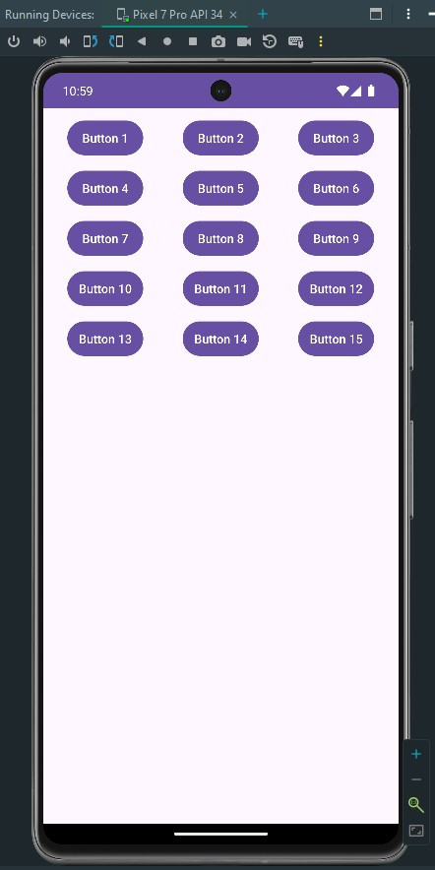

4.

Xml:

<?xml version="1.0" encoding="utf-8"?>

<RelativeLayout xmlns:android="http://schemas.android.com/apk/res/android"

xmlns:tools="http://schemas.android.com/tools"

android:layout_width="match_parent"

android:layout_height="match_parent"

tools:context=".MainActivity">

<ScrollView

android:id="@+id/verticalScrollView"

android:layout_width="match_parent"

android:layout_height="match_parent">

<TextView

android:id="@+id/textView"

android:layout_width="wrap_content"

android:layout_height="wrap_content"

android:textSize="30dp"

android:text="@string/long_text"/>

</ScrollView>

</RelativeLayout>

Java:

package com.example.scrollview;

import android.os.Bundle;

import android.widget.ScrollView;

import android.widget.TextView;

import androidx.appcompat.app.AppCompatActivity;

public class MainActivity extends AppCompatActivity {

@Override

protected void onCreate(Bundle savedInstanceState) {

super.onCreate(savedInstanceState);

setContentView(R.layout.activity_main);

ScrollView scrollView = findViewById(R.id.verticalScrollView);

TextView textView = findViewById(R.id.textView);

textView.setText(getString(R.string.long_text));

scrollView.setVerticalScrollBarEnabled(true);

}

}

Output: